Assignment 2
Evolutionary Delivery Planning : Cruise Control

This assignment can be done in pairs.

The case study attached presents a model (à la Ward and Mellor) of a Cruise Control system in brief form. The final system will run on a microprocessor system, and will be produced in large numbers.

Generate an Evolutionary Delivery plan for the system. Plan for at least five evolutionary steps. Each step must produce code as part ot the step.

For each step, indicate
1. your reason for the step’s definition,
2. what functionality will be delivered for that step,
3. who the "customer" is, and what hardware the build will be
developed and running on,
4. how each step will be tested.

Show a schedule with the deliveries of each step indicated (in the form of a Gantt chart). The schedule should have one line for each step, you are not required to provide more detail.

Provide a labour estimate for each step (in person-days). You may use an estimation method of your choice, but must have a good basis for your estimate.

The evolutionary delivery should have the following table of contents:

1. Introduction and Assumptions
2. Step Descriptions
2.1 Description of Step 1
2.1.1 Rational
2.1.2 Fuctionality Planned
2.1.3 Development and Target Environment
2.1.4 Customer
2.1.5 Testing
2.2 Description of Step 2 (same format as 2.1)
2.3 Description of Step 3 (same format as 2.1)
2.4 Description of Step 4 (same format as 2.1)
2.5 Description of Step 5 (same format as 2.1)
3. Schedule and Labour Estimate

Due: Hard copy in class, March 25, 2010
Cruise Control Problem Statement

The ordinary household thermostat performs closed loop control -- given a desired temperature setting, it monitors the actual room temperature and turns the heat on and off to keep the actual temperature close to the desired temperature. In maintaining a desired speed, the driver of an automobile does something quite similar; he or she monitors the actual speed by watching the speedometer, and depresses or releases the accelerator pedal to keep the actual speed close to the desired speed. A cruise control system relieves the driver of the responsibility for maintaining speed by taking over the closed loop control. The system described here is an add-on, which is installed after the automobile is purchased.
The Cruise Control System operates only when the engine is running, and is automatically reset to its “off” status when the engine is started. When the driver turns the system on, the speed at which the car is traveling at that instant is maintained. The system monitors the car’s speed by sensing the rate at which the wheels are turning and maintains the desired speed by monitoring and controlling the throttle position, as shown in the diagram. The monitoring is accomplished by a sensor that produces a signal proportional to the throttle’s position. The control is exercised by changing the degree of openness of a valve, which in turn controls a suction apparatus that draws on a chain to open the throttle. The throttle closes itself when not being actively controlled. After the system has been turned on, the driver may tell it to “start increasing speed,” which causes the system to increase the speed at a fixed rate. When the driver tell the system to “stop increasing speed,” it will maintain the speed reached at that point.
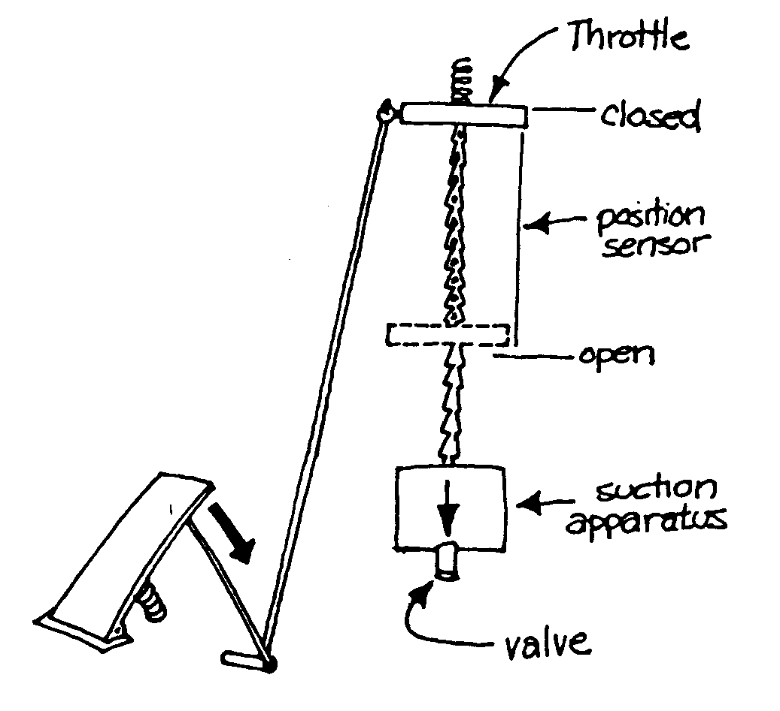
Figure 1 Hardware diagram
Of course, the driver may turn the system off at any time. In addition, the driver can override the system to increase speed simply by depressing the accelerator pedal. As shown in the diagram, this causes the chain controlling the throttle to go limp. During the period of greater speed, the system continues to attempt to maintain the speed previously set, and the system will return the car to the previous speed when the driver releases the pedal. If the system is on and senses that the brake pedal has been depressed, it will cease maintaining speed, but will not turn off. The driver may subsequently tell the system to resume speed (provided it hasn’t been turned off in the interim), whereupon it will return at a fixed rate to the speed it was maintaining before braking and resume maintenance of that speed.
The speedometers on many cars are inaccurate, and so this system incorporates its own speedometer. However, the speedometer must be calibrated when installed on a particular car. Since cars have tires of various sizes, the mileage equivalent of one wheel rotation can vary. The system thus accepts “start measured mile” and “stop measured mile” instructions, and resets its conversion factors to correspond to the number of wheel rotations sensed within the time period of the measured mile. This can only be done with the cruise control in “off” status.
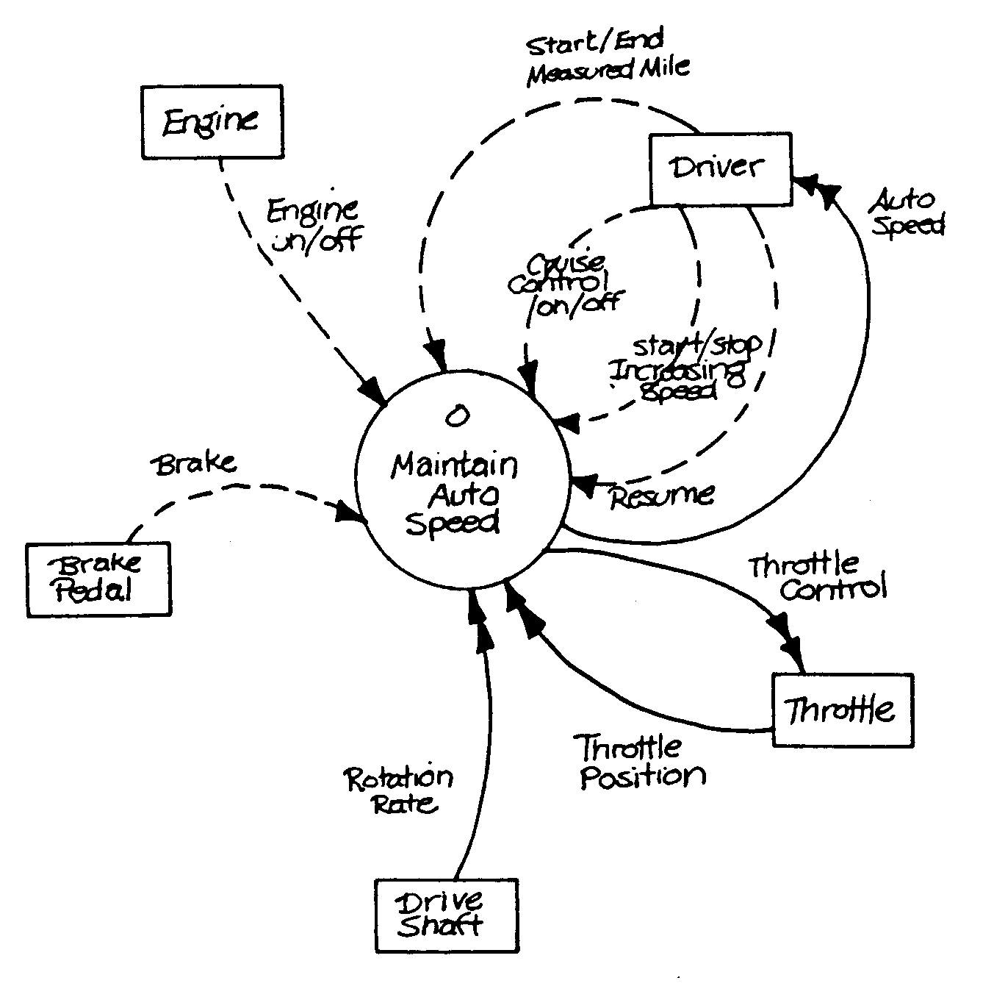
Figure 2 Context Diagram

Use Case List
- Engine starts up.
- Engine shuts down.
- Driver requests maintenance of current speed.
- Driver requests start of speed increase.
- Driver requests end of speed increase.
- Driver requests termination of speed maintenance.
- Driver indicates start of measured mile.
- Driver indicates end of measured mile.
- Brake pedal is depressed.
- Driver requests resumption of maintenance of previous speed after braking.
- Speed reaches previous value after braking.

Detailed Control Flow Diagrams

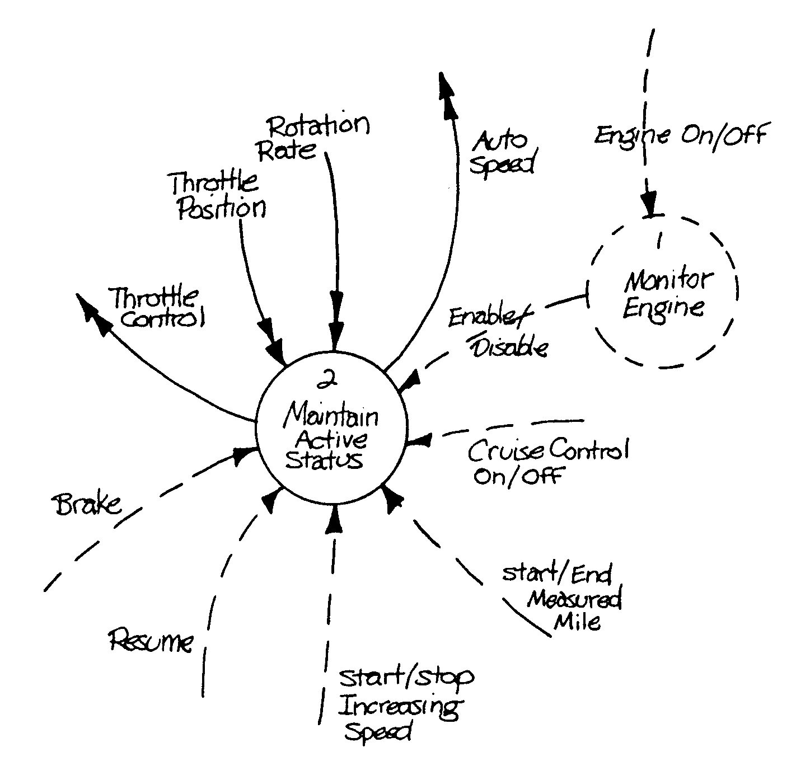
Figure A0 Maintain auto speed

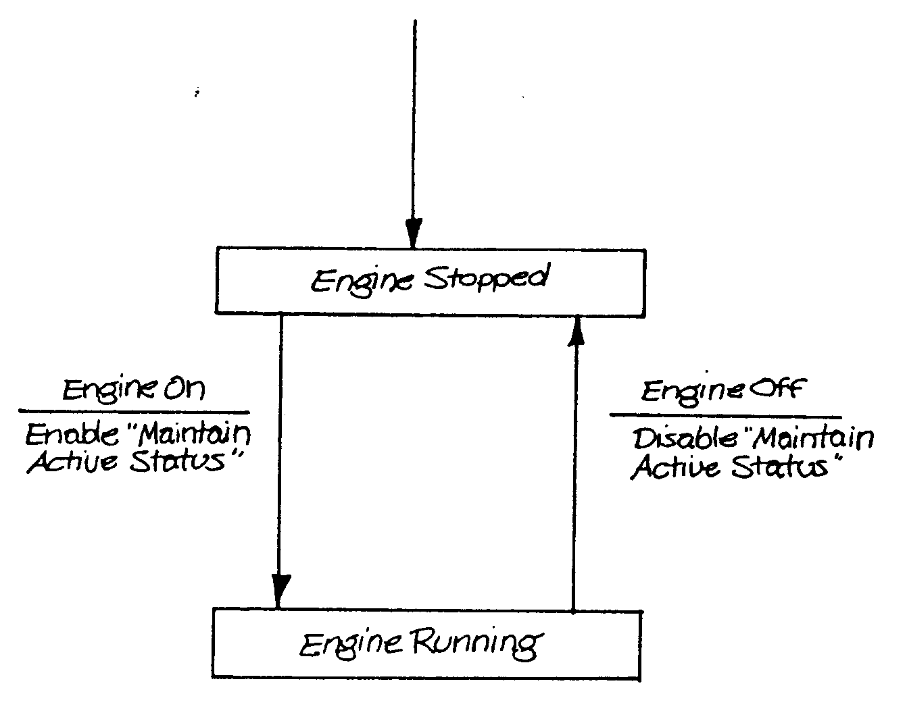
Figure A1 Monitor Engine
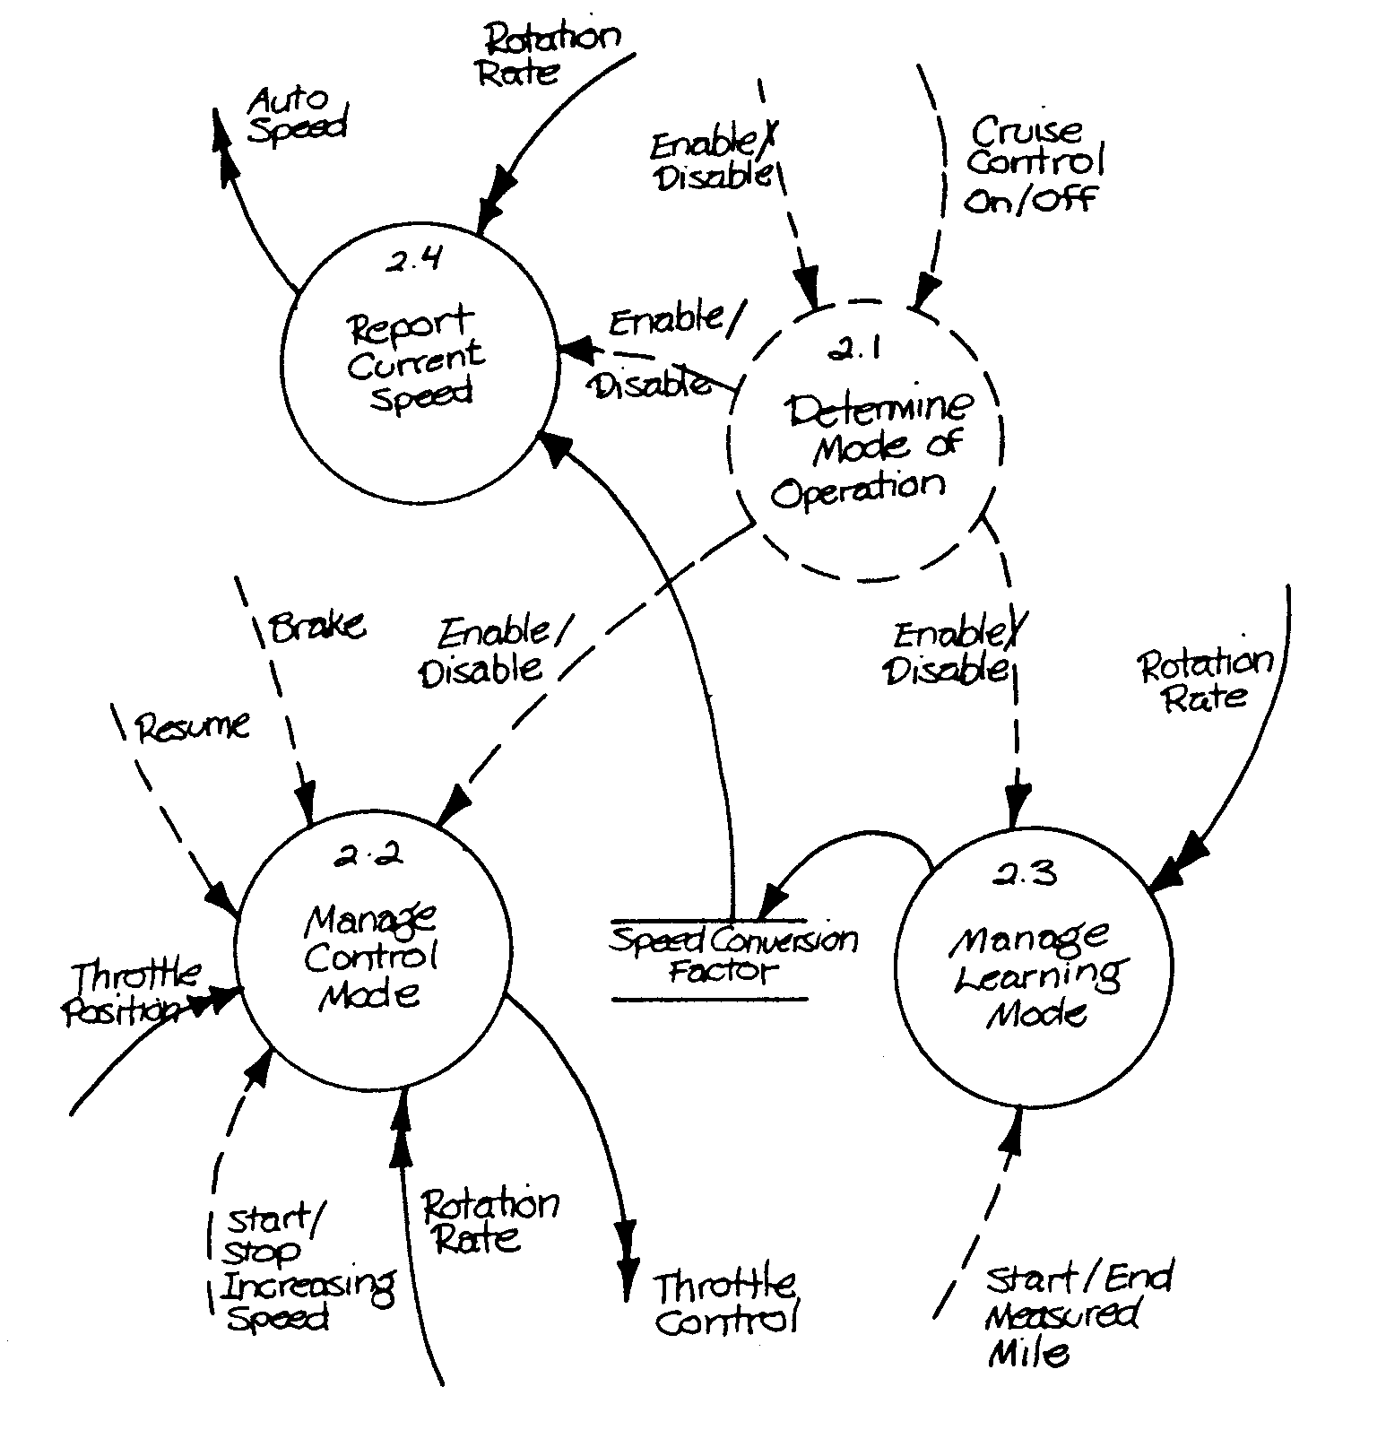
Figure A2 Maintain Active Status

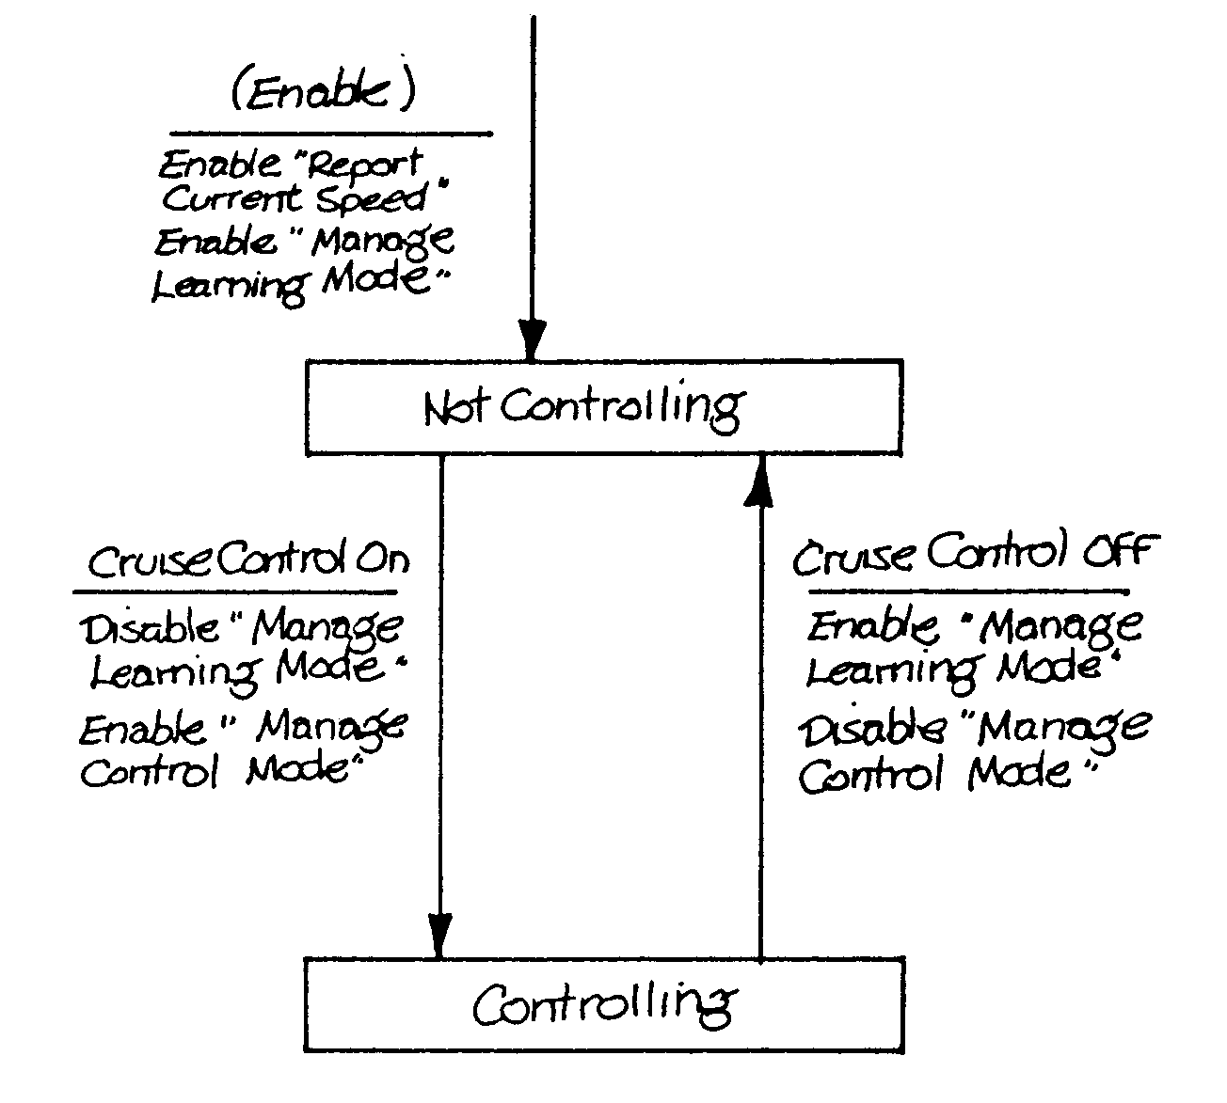
Figure A2.1 Determine Mode of Operation

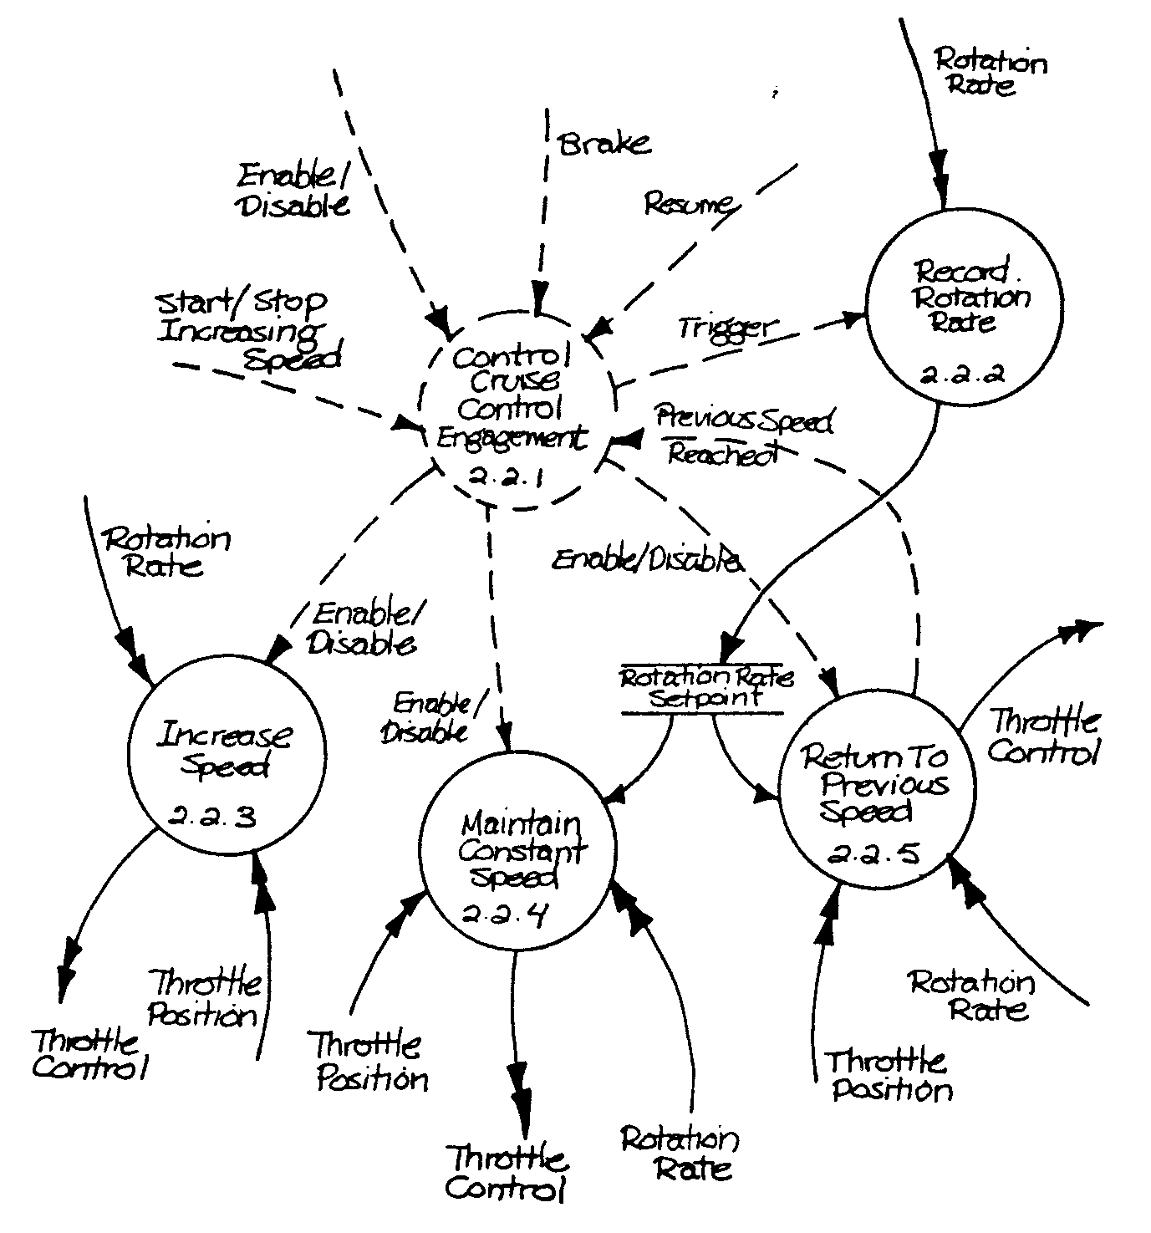
Figure A2.2 Manage Control Mode

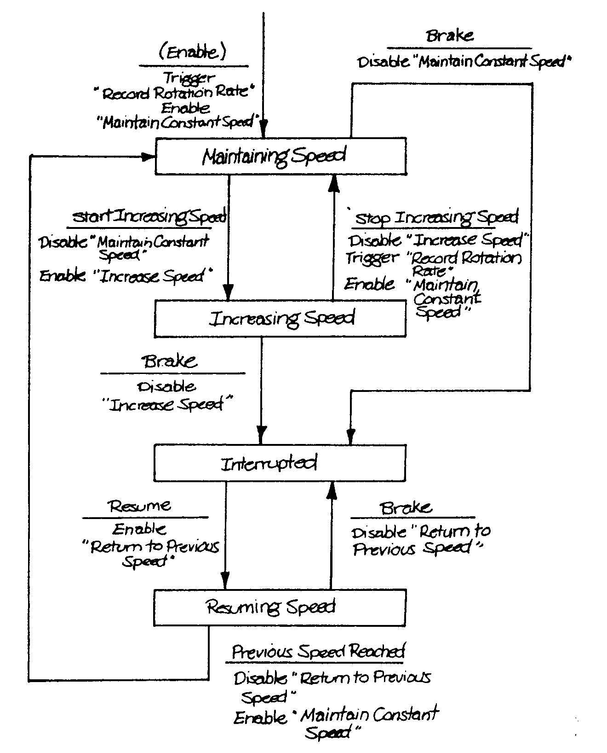
Figure A2.2.1 Control Cruise Control Engagement

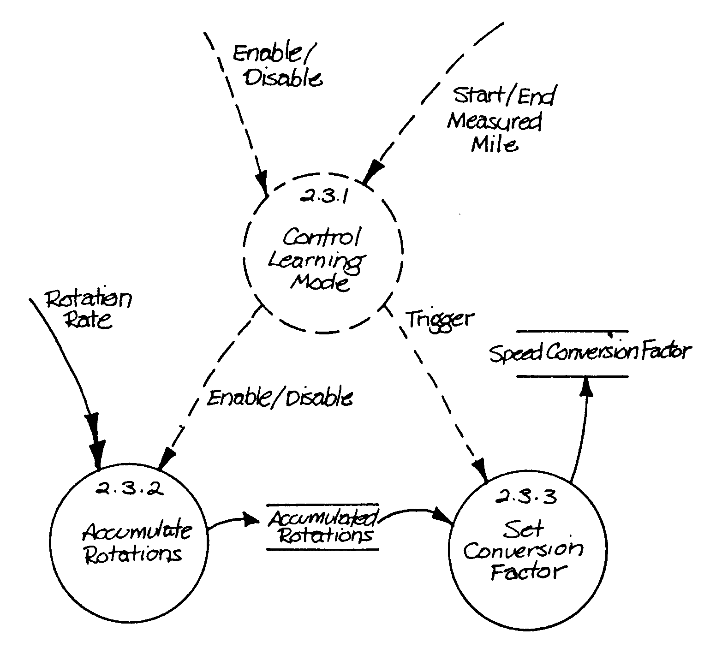
Figure A2.3 Manage Learning Mode

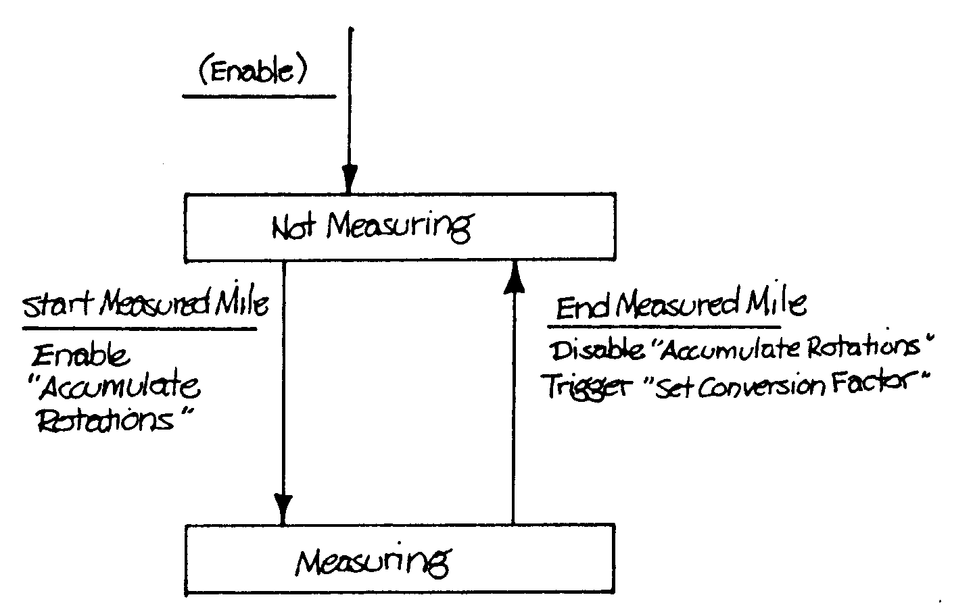
Figure A2.3.1 Control Learning Mode

